Create an infographic illustrating the Test-Driven Development (TDD) process. Highlight steps like writing tests before code, benefits such as bug reduction, and how it fosters software reliability.

**The Test-Driven Development (TDD) Process**

**Introduction to TDD**

**Definition:**

Test-Driven Development is a software development process that focuses on writing tests before writing the actual code.

**Steps of TDD**

* Write a failing test: Start by writing a test that defines the desired functionality.
* Write the code: Implement the code necessary to make the test pass.
* Refactor: Improve the code without changing its functionality.
* Repeat: Continuously add new tests and refactor existing code.

**Benefits of TDD**

* Bug Reduction: By writing tests first, developers catch bugs early in the development process.
* Improved Code Quality: TDD encourages writing modular, reusable, and maintainable code.
* Faster Development: Despite the initial time investment in writing tests, TDD can lead to faster development in the long run.
* Better Software Reliability: With comprehensive test coverage, the software becomes more reliable and less prone to errors.

**Illustration**

Visual representation of the TDD process, with a flowchart or diagram showing the iterative nature of writing tests, code implementation, and refactoring.

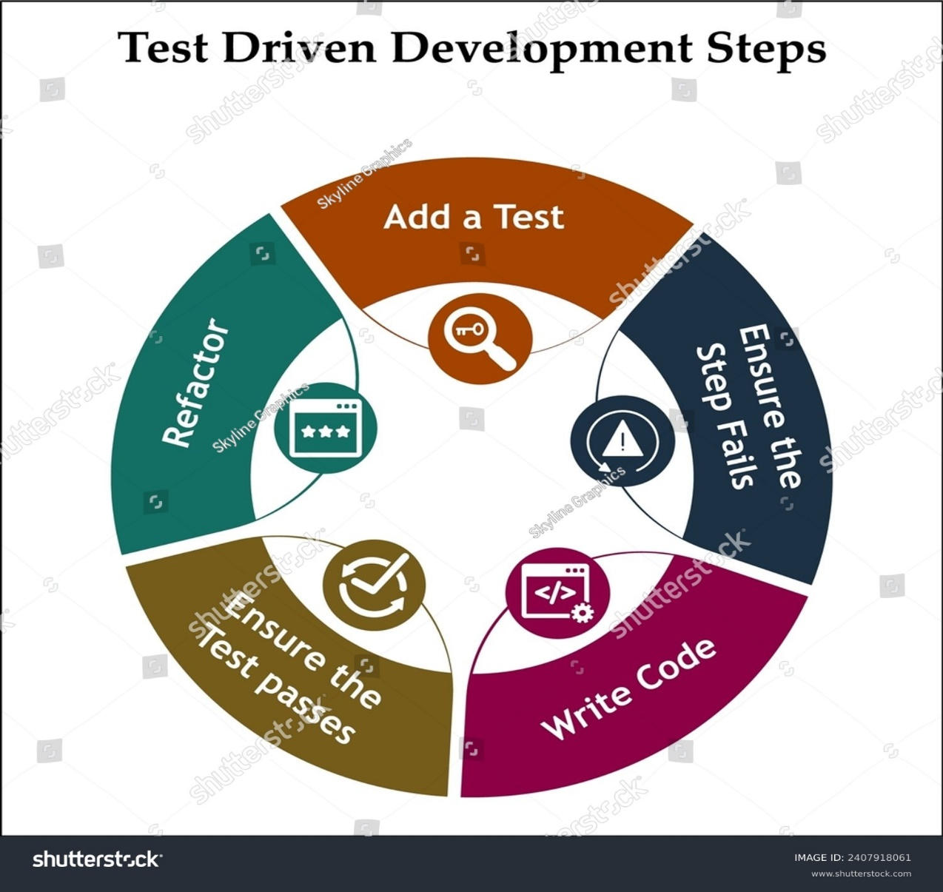

**Conclusion**

Test-Driven Development is a proven method for producing high-quality software with fewer bugs and greater reliability. By following the TDD process, developers can build robust software that meets user requirements efficiently.